SYLLABUS: EDU 455/C&I 555
Learning from Finland: Best Practices for Teaching and Learning
Spring 2020
2 credits
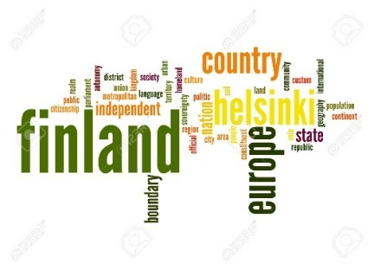

Instructor
Ann Ellsworth, PhD (ann.ellsworth@montana.edu)
Required Text
Sahlberg, P. (2015). Finnish Lessons 2.0. New York: Teachers College Press.
ISBN 978-0807755853

Additional Readings and Resources
CIA World Factbook: Finland. https://www.cia.gov/library/publications/the-world-factbook/
European Literacy Policy Network. (2016). Literacy in Finland Country Report. http://www.eli- net.eu/fileadmin/ELINET/Redaktion/user_upload/Finland_Long_Report.pdf
OECD PISA Website: http://www.oecd.org/pisa/
Robinson, K. (2006). Ted Talk. “Do schools kill creativity?” https://www.ted.com/talks/ken_robinson_says_schools_kill_creativity
Shanahan, T. (2015). “Finland’s ‘joyful, illiterate kindergartener.” Thomas B. Fordham Institute. https://edexcellence.net/articles/finlands-joyful-illiterate-kindergarteners
Walker, T. (2015). “The joyful, illiterate kindergartners of Finland.” The Atlantic. https://www.theatlantic.com/education/archive/2015/10/the-joyful-illiterate-kindergartners-of-finland/408325/

Course description: This 2-credit self-paced course is designed to develop participants’ knowledge of the Finnish model of education. We will study the teaching philosophy and practices of Nordic educators that result in students performing as world leaders on national assessment measures in core areas of reading, mathematics, and science.

Learning outcomes:
Upon completion of this course, participants will be able to:

- Compare and contrast the Finnish compulsory education system with the American Pre-K12 public school system.
- Describe Finland’s approach to teaching two national languages: Finnish and Swedish.
- Describe the history of the PISA assessment and Finland’s performance in the three core areas.
- Identify aspects of Finnish culture, including the indigenous Sami people.

Major Topics
Overview and foundational language principles
Finland’s model for instruction
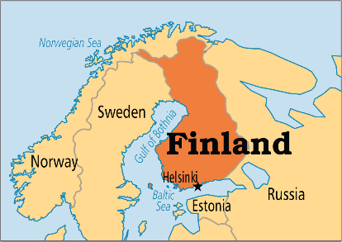
Recent educational reform measures
Cultural factors that support schools and educators
Finland’s performance on international assessments (PISA)

Teacher preparation
Rigor and length of programs
Percentage of students accepted into teacher training
Teaching is considered prestigious career choice

Instructional best practices in Finland
Educational mission: Schools and families as partners
Students are trusted
Communities value education, not sports
Frequent breaks & shortened school days
Expert instruction by master-level teachers

Grading
Total Points Available: 100

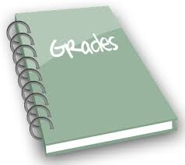
93-100 A
85-92 B
77-84 C
76-70 D
69 or lower F

Discussion Requirements
- Posting requirements
- There is a sense in the posting that ideas lead to each other and connections are being made. The posting is more than a summary.
- The initial post integrates readings with the world of practice.
- The post meets the length specification (at least 300 words.)
- There are no distracting English language conventions that would interfere with the meaning the writer wants to convey and the meaning the reader is seeking.

- Reply requirements
- The reply posting is not merely commentary or “I agree with you” type of (passive thinking) response; these are not casual entries as if in a blog. Instead, there is evidence of higher-level thinking.
- Each reply meets the length specification (at least 200 words.)
- There are no distracting English language conventions that would interfere with the meaning the writer wants to convey and the meaning the reader is seeking.
Adapted from: Worchester Polytechnic Institute. (2010). Academic Technology Center: Teaching with technology collaborator. Retrieved June 28, 2010 from http://www.wpi.edu/Academics/ATC/Collaboratory/Idea/gradingdiscussions.html

- Evaluation
- Full credit/10 points = All requirements met. Furthermore, contributions were particularly insightful.
- Partial credit/7-9 points = Missing 1 requirement; submission meets minimum expectations for a professional post.
- Partial credit/4-6 points = Missing 2 requirements; submission lacks in substance.
- Partial credit/1-3 points = Several requirements missing.
- No credit/0 points = Missing discussion assignment/no response.

How to submit an assignment on Moodle
Links to assignments can always be found in the sections down the center of the Moodle course page.
- Click the link to the assignment.
- Click Add submission.
- To enter online text, type directly into the Online text box.
- To submit a file using drag-and-drop.
- Browse for a file.
- Click Upload.
DESCRIPTION OF ASSIGNMENTS
CIA World Factbook Assignment (25 points)
Research several topics (government, history, geography, language) using the CIA World Factbook website. Create a PowerPoint with a minimum of 20 slides that shares fascinating information about these various topics. Suggestion: Design riddles with answers on subsequent slides or explore other creative approaches.

https://www.cia.gov/library/publications/the-world-factbook/

Discussions (30 pts.)
Respond to the three discussion topics, based on readings and other assignments, which are intended to help you make connections between what you know about schools, what you are learning in this class, and how these understandings will help you reflect on your own educational practice. See Discussion requirements on p. 2 of this syllabus.

Comparison of Two Education Systems (25 pts.)
Synthesize what you’ve learned in a 3-4 page (minimum) paper (d.s.) Reference course material and use APA formatting on your reference page, which is titled References (not Works Cited.)

Reflection Paper (20 pts.)
For graduate-level participants only. Drawing from our readings and course material, prepare a 2-3 page (d.s.) reflection that discusses what you’ve learned about Finland’s approach to teaching and learning. Reflect on what changes you plan to make in your instruction and explain how you might realize these goals. Use APA formatting when referencing any outside sources.

SCHEDULE
Week | Topics | Assignment
1 | - Introductions and course overview | - Discussion Board Introductions.
2 | - Introduction to Finland: CIA World Factbook | - CIA World Factbook—Be the Expert! Create a narrated PowerPoint (4-5 minutes) about your category.
3 | Sahlberg pp. 1-53, 237  - We can learn from Finland  - The Finnish Dream: A Good School for All | - Discussion Board post #1 of 3 and responses (pp. 1-53, 237). One original post and at least one reply. (10 pts.)
4 | Sahlberg pp. 54-97  - The Finnish Paradox  - History of PISA assessment and analysis of student performance data  OECD PISA Website: http://www.oecd.org/pisa/ | - Discussion Board post #2 of 3 and responses (pp. 54-97). One original post and at least one reply. (10 pts.)
5 | Sahlberg pp. 98-138  - The Finnish Advantage  - Creativity in Schools  - TED Talk on creativity in education  https://www.ted.com/talks/ken_robinson_says_schools_kill_creativity | - View Sir Ken Robinson’s TED talk and take notes to include in your comparison paper.
6 | Sahlberg pp. 139-172  - The Finnish Way  - “The Joyful, Illiterate Kindergartners of Finland.” The Atlantic. https://www.theatlantic.com/education/archive/2015/10/the-joyful-illiterate-kindergartners-of-finland/408325/  - Shanahan, T. (2015). “Finland’s ‘joyful, illiterate kindergartener.”  - https://edexcellence.net/articles/finlands-joyful-illiterate-kindergarteners | - Discussion Board post #3 of 3 and responses (pp. 139-172). One original post and at least one reply. (10 pts.)
7 | Sahlberg pp. 173-206  - The Finnish Future | 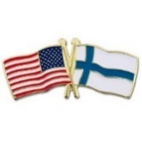  - Comparison of Two Education Systems paper (25 pts.) 3-4 double-spaced pages minimum. Reference course material, APA style.
8 | - Second language learning model  - Indigenous populations and neighboring countries | - Reflection Paper (20 pts.) 2-3 double-spaced pages minimum. Reference course material, APA style.

