**Maximizing Mentor Texts: Teaching Writing in a Connected Way**

**Spring 2020**

**2 credits**

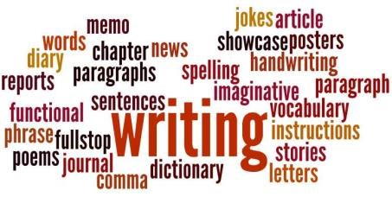

**Dates**:

Actual duration of course according to UM’s spring 2020 semester schedule.

**Course description**: This two-credit course explores how mentor texts can be used to jump-start analytical writing: writing arguments, writing to inform, and writing to explain (Common Core Anchor Standards 1 through 3.) Starting with structured, scaffolded assignments for developing writers and then growing these to more complex writing activities, participants will problem solve, using creative and critical thinking to develop a set of strategies that target the improvement of their students’ written communication.

**Required texts:**

*Write Like This*

Author: Kelly Gallagher

Stenhouse Publishers, 2013

ISBN: 9781571108968

*Beyond the 5-Paragraph Essay: How to Write Analytical Essays*

Authors: Kimberly Campbell and Kristi Latimer

Stenhouse Publishers, 2012.

**Learning outcomes:**

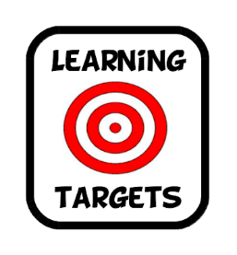Participants will be able to

1. Describe the elements of effective written communication.

2. Contrast analytic writing forms from narrative structures.

3. Locate mentor texts that match to aspects of effective writing (namely, word choice, organization, and sentence structure.)

4. Explain how close reading aids in “reading like a writer.”

5. Evaluate published writers’ words and use of phrases.

6. Examine grade-level writing standards and design appropriate analytical writing assignments.

**Grading summary:**

A 90-100

B 80-89

C 70-79

D 60-69

Note: “Plus” and “minus” are the two high and low end percentages for each grade range.

**Summary of Requirements, Points, and Due Dates:**

|  |  |
| --- | --- |
| **Requirement** | **Points** |
| Introduction assignment | 5 |
| Personal writing with mentor texts (choice) | 10 |
| Reading reflections | 30 |
| Analytic Writing Showcase | 30 |
| Word collections | 15 |
| Final paper | 10 |



**→Evaluation of Assignments and APA format:** You are expected to submit high quality written products that adhere to the requirements outlined by the 6th edition of the American Psychological Association (APA) publication manual. A helpful resource follows: <https://owl.english.purdue.eduowl/resource/560/01/>

**→Submit an Assignment on Moodle**

1. Links to assignments can always be found in the sections down the center of the Moodle course page.
2. Click the link to the assignment.
3. Click Add submission.
4. To enter online text, type directly into the Online text box.
5. To submit a file using drag-and-drop.
6. Browse for a file.
7. Click Upload.

**DESCRIPTION OF ASSIGNMENTS**

**1. INTRODUCTORY ASSIGNMENT** (5 points)

Write an introductory essay that (1) tells us about you, your teaching experience (and your family, if you wish), (2) shares the writing you do as part of your job, and (3) describes 2-3 course goals you have the concern writing improvement—either for yourself as a teacher or for students.

**2. PERSONAL WRITING WITH MENTOR TEXT(S)** (10 points): Study the options provided in the list below (taken from *Write Like This* by teacher Kelly Gallagher) and choose one. Your composition should be 250-400 words. Foreground your choice, explaining *why* you selected this particular activity—what “grabbed you” as you surveyed these assignment options. A short paragraph will suffice as an introduction to your selected assignment. Identify the word count on your final entry.

* My favorite mistake (pp. 29-35)
* A favorite (neighborhood) spot (p. 35-36)
* What my childhood tasted like (pp. 44-45)
* Childhood games (pp. 45-46)
* A hard moment or watermark event (pp. 46-49)

**2. READING REFLECTIONS** (30 points)

Read the file tiled “Reading Reflections” and choose three assignments. Your task is to elaborate on the implications for classroom teachers.

**3. WORD COLLECTIONS** (15 points)

This assignment is an opportunity to pay attention to how writers use words in powerful ways. We know that good writers pay attention to language use; accordingly, we want to heighten our awareness of words. Consider this: When you read something that gives you pause and makes you take notice, the author has achieved his/her goal in communicating effectively with you, the reader. Often it is not just a word or two, but how the entire sentence is structured.

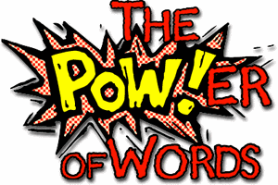To complete this assignment, become a word detective. Read pp. 41-44 in *Beyond the Five-Paragraph Essay*. Keep a log of interesting words and/or phrases that you encounter in your daily reading. Minimum number of examples: 20. Make it your goal is to expand your speaking and writing vocabulary with the discovery of powerful word choice. How you decide to organize and personalize your e-notebook is up to you.

The ubiquity of beautiful prose is evident across all types of reading material from fiction to nonfiction and from short bits to lengthy pieces. For example, within the last year, I have read Jon Krakauer’s *Into Thin Air* and *Into the Wild*. He’s most adept at word choice, and I often learn words. Find your own sources of quality writing and become a language sleuth.

**4. WRITING SHOWCASE** (30 points)

This assignment is designed to improve your instruction in analytical writing: making an argument, writing to inform, and writing to explain. With each of the three assignments you structure, also do it yourself as an example you might share with your students. As you create each modeled example, focus on clarity and organization of ideas, word choice, word economy (see p. 185 in Campbell/Latimer text), language specificity, sentence structure, and rhetorical devices. Examples will be shared.

Use teaching ideas from our authors, Kelly Gallagher, Kimberly Campbell, and Kristi Latimer, and identify the mentor text(s) you are using to help guide your students. For example, you might like the Look Closely writing exercise, described on pp. 86-87 in *Write Like This*, where the teacher uses Frank Serfini’s series of Looking Closely books as mentor texts to foreground a writing assignment.

Another way to think about this assignment….

You might already teach literary analysis but want to bump up this assignment, given what you now know from our readings. Accordingly, you would describe the assignment (and your plans for upgrading it.) Note: Chapter 3 in Campbell/Latimer text is particularly helpful. The authors provide examples of assignments that focus on character development, the role of setting, how theme is developed, and the use of symbolism and motifs. While their examples are with high school texts, for example, *To Kill a Mockingbird*, you can adapt their ideas to fit your grade level and curriculum.

The Writing Showcase assignment is due upon the conclusion of this class. As this course is self-paced, please negotiate your personal timelines with the instructor.

OPTION: As well, if you have other ideas for how you can modify this assignment so it is a better match for what you do as a teacher, contact the instructor. She will work with you so you can streamline what you do as a teacher and what you do as a (graduate) student taking this class. Our purpose is to advance students’ written communication in intentional, meaningful ways.

* Create/design three analytic writing assignments
* Identify the mentor texts you are using.
* Include a detailed assignment description.
* Complete the assignment yourself.
* Prepare as one docx file.

**5. FINAL PAPER** (10 points)

For students who are taking this course for graduate credit:

Write a paper that traces what you’ve learned about the composition process and how teachers help develop students’ writing skills. Suggested length: 4-6 pages, d.s.